Ref. No. JSSA/AL/02202933
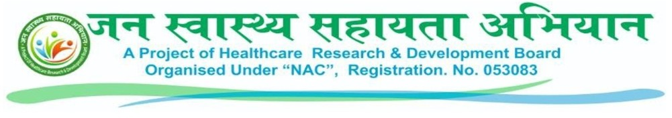
Letter of Authorization
To,
Dear Mr./Mrs.: ANIL SINGH
S/O(D/O): NAVAL SINGH
DOB: 17/11/1990
Application No: 20259453430
Employee ID : JSSA/BR/DM/123456

Subject: Authorization for the post of DISTRICT Manager in our organization.

Our organization is delighted offer you the authorization of DISTRICT Manager for Dausa (Rajasthan) on probation period for three months from the date of appointment. On expiry of the probationary period it is open for the management either to confirm your services or extend your probationary period. Such an extension can be granted for a maximum of 11 months more, The Management, however, reserves the right to terminate your services without assigning any reason during the probationary period, or the extended probationary period. However, during the probation period, services can be discontinued without any notice.

Your selection has been made on the basis of educational qualification, experience and interview.

As the DISTRICT EXECUTIVE, you will be responsible for full-fill the target of our organization’s project JAN SWASTHYA SAHAYATA ABHIYAN in your jurisdiction where you are posted & follow the instructions of your senior officer.

Your employment with our organization will be on contract basis, which means you and the organization are free to terminate employment at any time, with or without cause or advance notice.

If you meet the monthly target set by the organization, your initial income will be ₹25,500 per month. If you do not meet the monthly target set by the organization, then you will receive ₹127 for each card created by you, and ₹10 per card for each card created by the Panchayat Executive and Block Supervisor of your district. This amount will be credited to your wallet. You can transfer the credited amount from your wallet to your bank account.

In addition to the national holiday, you will be granted 18 casual leave in a year for which you will have to inform your senior officer of organization. If you are absent for 11 consecutive days in a month without notice, your service will be terminated by giving you a notice.



You will report directly to our HR department on email: joining.HR@JSSABHIYAN.COM Working hours are from 10:00 AM to 06:00 PM (Every day of week) Please confirm acceptance of this offer by signing and returning this letter within 5 days from the date of issue.

Yours Sincerely
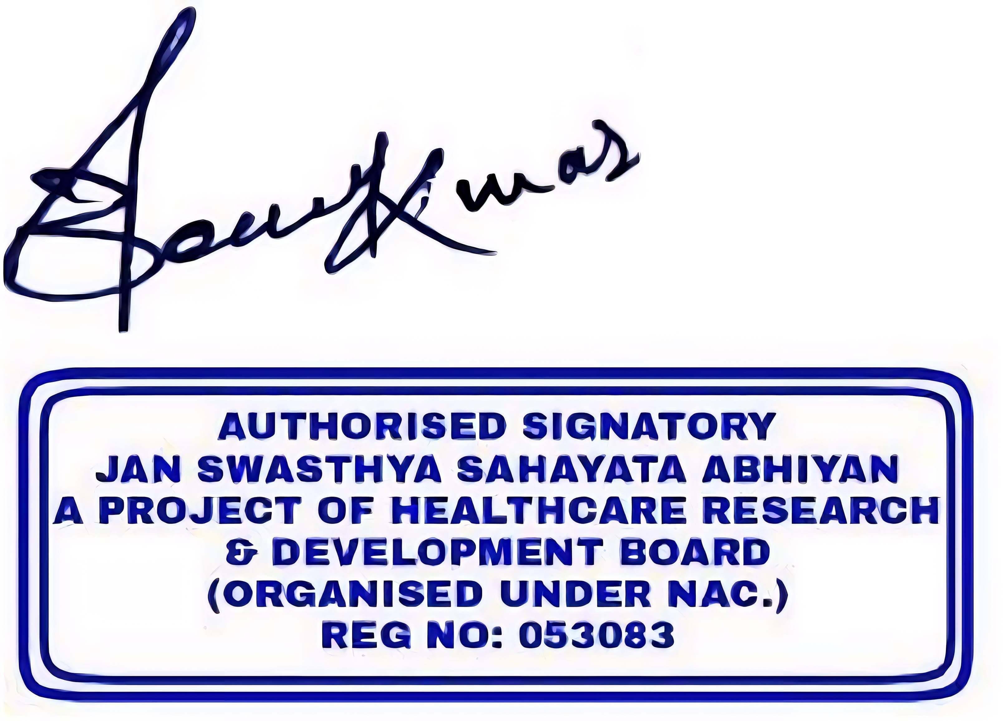
JAN SWASTHYA SAHAYATA ABHIYAN
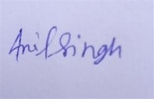

For JAN SWASTHYA SAHAYATA ABHIYAN mou_2933 District Manager
HR Department Date: 11/17/2025 2:19:20
JAN SWASTHYA SAHAYATA ABHIYAN Place : Dausa (Rajsthan)
A project of Healthcare Research and Development
(Organized under NAC RegNo:053083)
Registered under Companies Act 2013 under the provision of section 8

